# Performance and Load Testing (JMeter)

## Purpose

The purpose of testing the web performance and load testing is to ensure that the FullMetalLibrary application can perform under concurrent user access. The test has been conducted to evaluate that the system can handle normal user usage for reliability and does not degrade in performance when in use.

## Test Setup

Apache JMeter v5.6.3

A thread Group was created with the following:

* Number of Threads: 20
* Ramp-Up Period: 5 seconds
* Loop Count: 1
* Same User on Each Iteration: Enabled

Each thread is a representation of a user accessing the application at the same time to demonstrate real usage. The number of users were set to 20 with a 5 second ramp up for realistic traffic without an unrealistic amount of users on the local environment.

The following pages were tested:

1. HTTP Home Page: /
2. HTTP Login Page: /Admins/Login
3. HTTP Register Page: /Admins/Register
4. HTTP Books Page: /Books
5. HTTP Authors Page: /Authors
6. HTTP Admins Page: /Admins

Each user accessed the above main pages, as they are the most ‘frequented’ parts of the system, which will offer a reliable overview of the performance. The other routes not tested included specific ID’s, depend on seed data, and database entries which does not represent the general user traffic and may conclude in inconsistent test results.

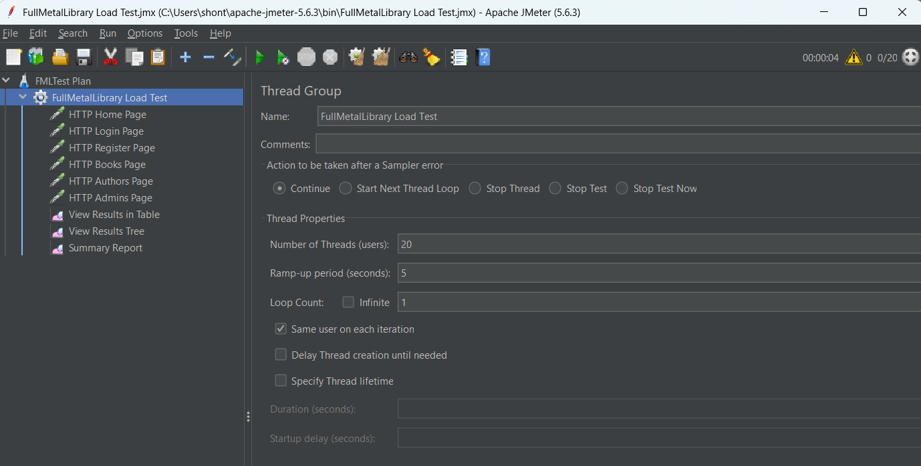

Figure : FullMetalLibrary ThreadGroup.

## Test Results

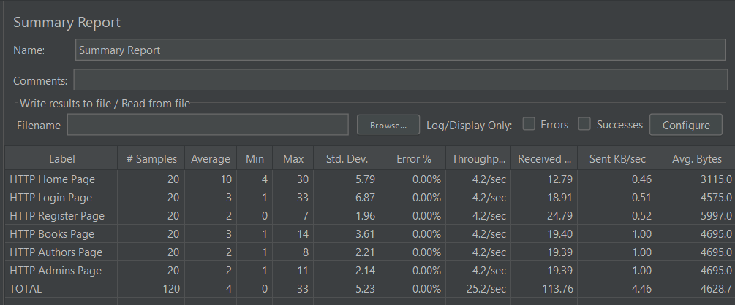

Figure : JMeter Summary Results for FullMetalLibrary.

## Interpretation of the Results

The selected report to discuss the results of the test are from the generated JMeter Summary Report.

* The average response time is 4ms, this shows an excellent performance rate, all the end points were able to respond well under the load.
* Minium/Maximum resulted between 2ms and 12ms, it shows stable response times without much variation.
* The standard deviation was able to stay below 5ms on all of the tested pages, showing consistency across the requests.
* The error rate 0% is confirmation that all the requests were processed successfully.
* Throughput at 25.2/sec shows that the application could handle the concurrent requests efficiently.
* The received KB/sec averaged at 18KB/sec, this is confirmation of efficient data transfer and light page size.

The results of this test are able to show that the FullMetalLibrary application can maintain stability and speed under normal concurrent access. It is able to handle 20 concurrent users without any failed requests. The system was able to maintain fast response times and was consistent across each page tested, with no reported signs of degradation or instability.